# Tracking FreeD PTZ Cameras using

Currently we support Panasonic AW-UE100 and AW-UE150 , Sony BRC- X1000, Lumens VC-A71P.

**First** you need to setup proper tracking settings in your camera. For Panasonic it can be done by next steps:

1. Go to the browser settings page of the camera

Setup / Tracking Data Output / IP Out

We tick at least one client, for example Client 1

Assign the IP address of the computer on which AllMix is ​​installed to the selected client

We assign some Port to the selected client, for example 52381

Press the Set button

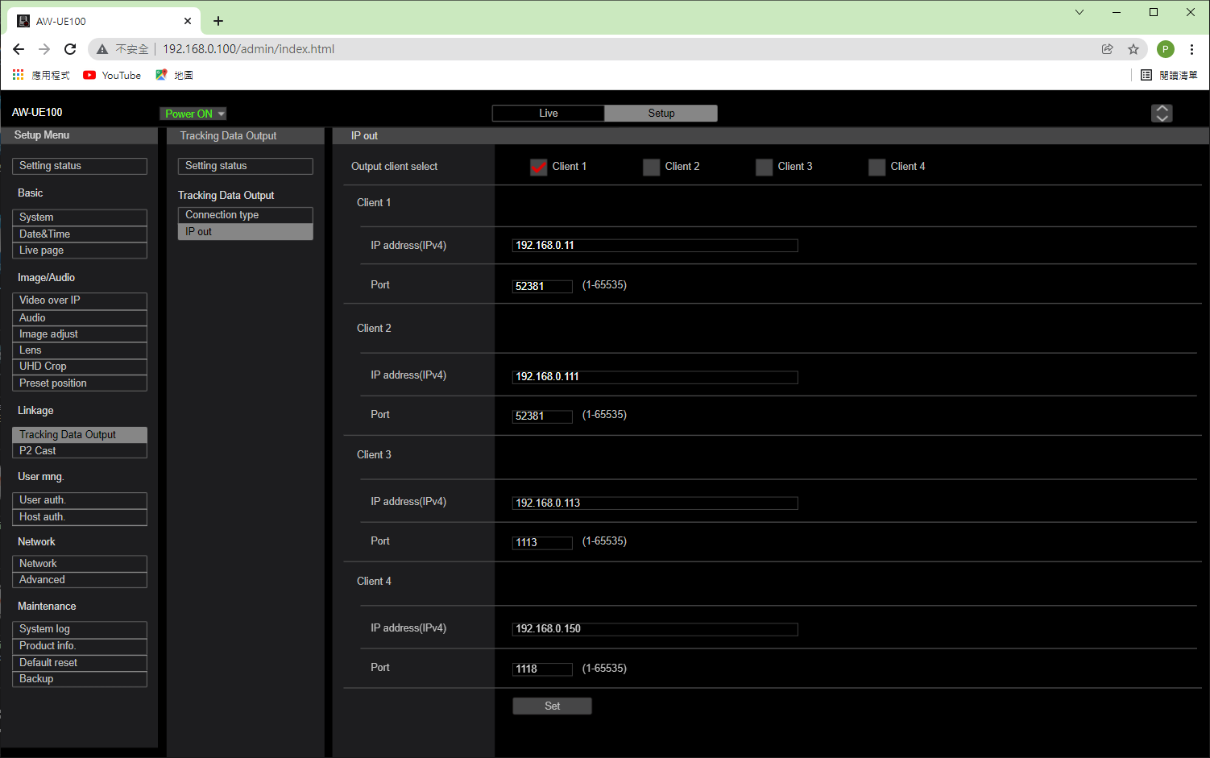

1. Go to the Setup / Tracking Data Output / Connection Type page and set the IP(UDP) mode

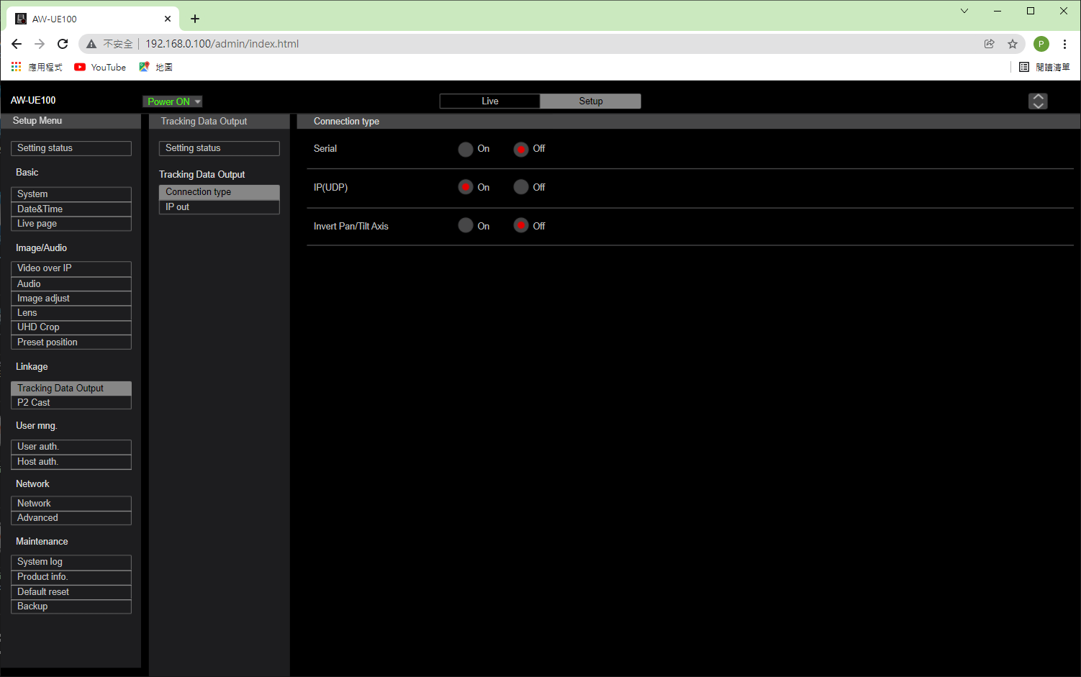

**Second** – You need to setup same framerate on all devices: cameras, capture boards and monitors. Otherwise smooth movements on your video will be impossible to obtain. For Forward boards (FDExt) you need to run FDConfig2 and set the frame rate to the same as the FreeD camera.

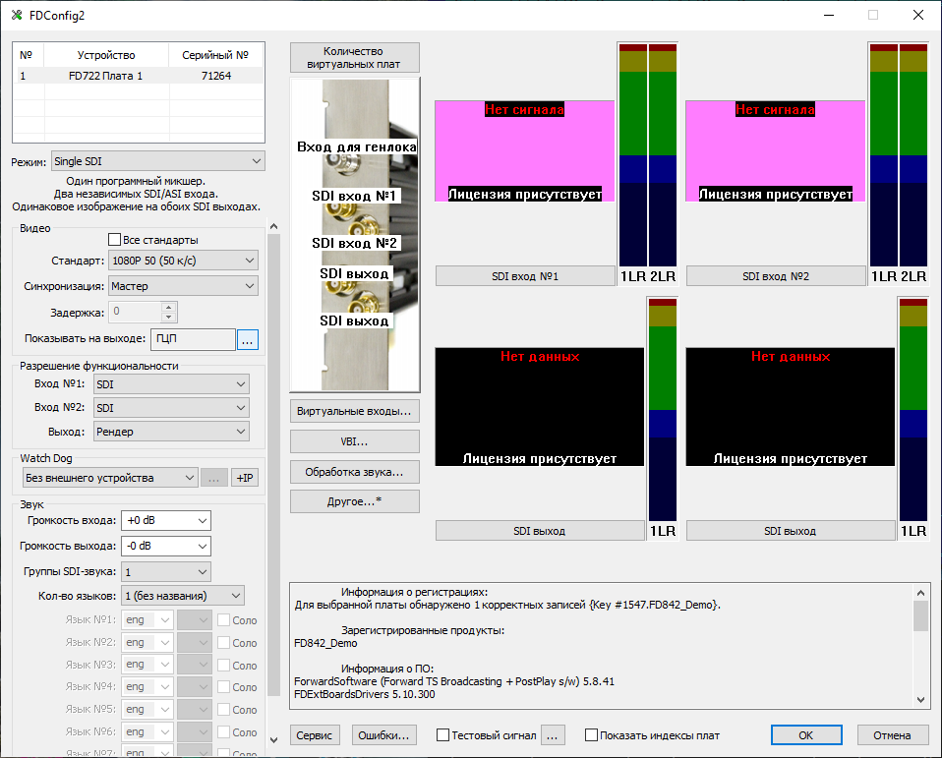

On all monitors, set the frame rate to the same as that of the FreeD camera.

**Third** - To check how tracking works you need to use special test scene and project by next steps:

1. Run AllMix project Tracking.mixer in presentation mode (F3)

Assign a camera from the Live FD Boards (or other capture boards) list to Slot 8

Go to the Slot 8 editor and turn on the PTZ Controller

In the properties of the PTZ Controller, select proper protocol (the NDI protocol for Panasonic, for example), and in the address field, select the desired camera from the drop-down list

1. Go to the Slot 9 editor, where the 3D scene Tracking.fbx is located

Find the overlay material named Reality and assign

Input = Slot8

tracker=on

Tracker Port = 52381 (same as in camera settings)

Tracker Delay = 80 (selectable delay)

Tracker Calibration = file AW-UE100.calibration (or VC-A71P_Lumens.calibration etc.)

Tracker Offset changes the angle between virtual 3D camera and real PTZ camera

1. If everything is set up correctly, then when the PTZ camera turns and zooms in, the virtual camera simultaneously rotates and changes the focal length, as a result, it seems that the virtual scene complements the real video.