1. **Setting the SRT output stream:**

In the top toolbar, open the Tools → Settings

The settings menu can also be called up by pressing the F10 key:

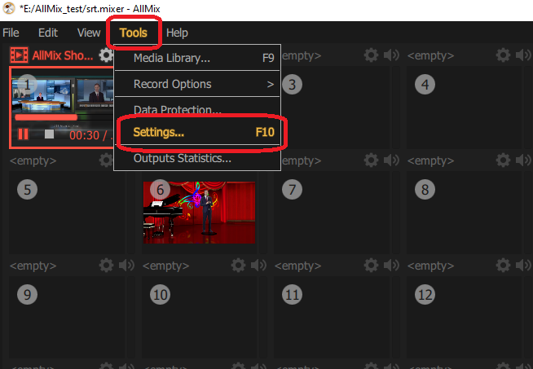

Setting output stream parameters

- **Name** - default value is Stream, you can set your own name.

- **Content** - default value is Program, serves as a source. Clicking on the content shows a list of slots that can be assigned as a source for the output stream.

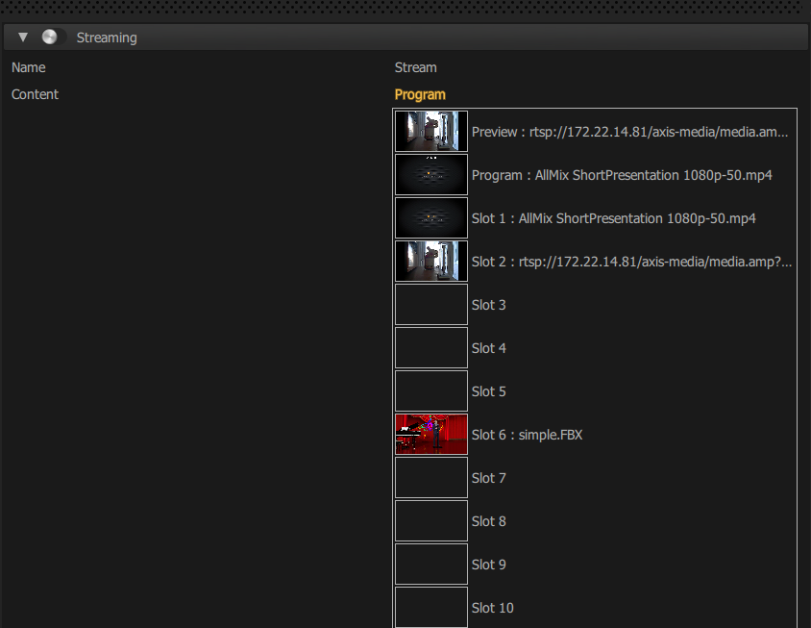

**- URL -** srt://172.22.14.203:10889 (example)

172.22.14.203 - IP address of the computer from which the broadcast is being conducted (localhost can only be used when broadcasting "to itself"). 10889 - any free network port.

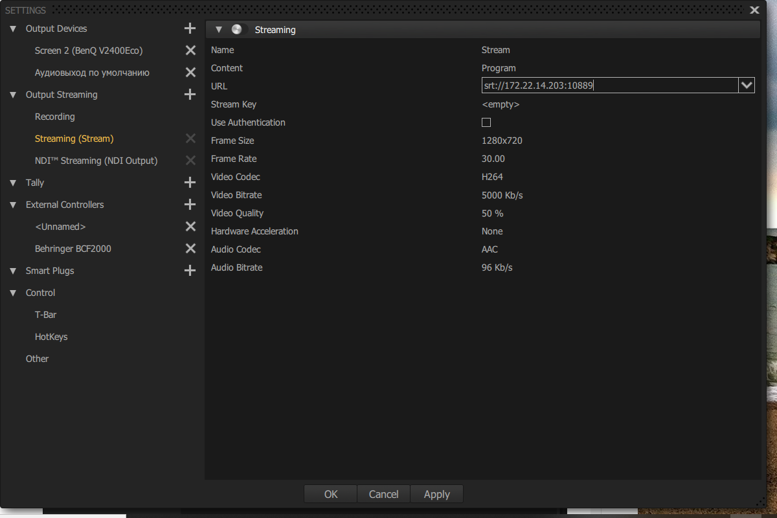

Adjust other parameters as needed:

**- Stream Key** - default value is <empty>

**- Use Authentication** - disabled by default, to connect check the box and fill in the fields:

- User Name

- Password

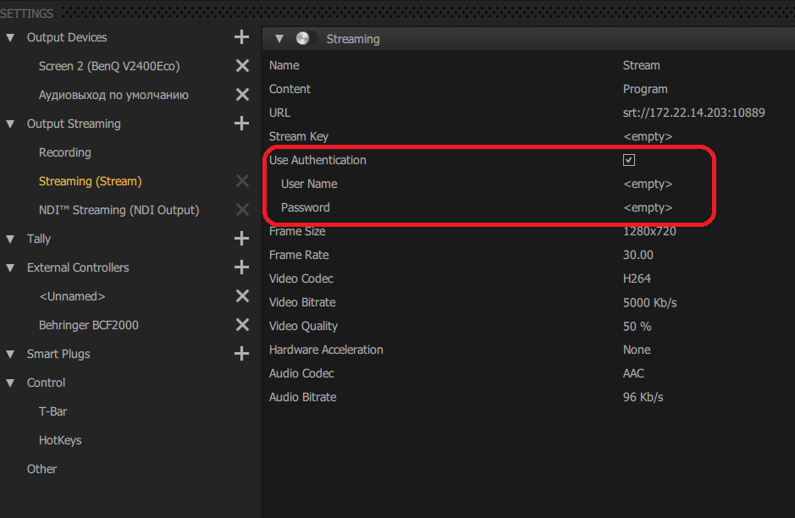

Broadcast signal format parameters:

**- Frame Size** - default value is 1208х720

**- Frame Rate** - default value is 30.00

**- Video Codec** - default value is Н264

**- Video Bitrate** - default value is 5000 Kb/s

**- Video Quality** - default value is 50%

**- Hardware Acceleration** - default value is No

**- Audio Codec** - default value is AAC

**- Audio Bitrate** - default value is 96 Kb/s

After setting the parameters, move the Streaming switch to the working position and save the settings: Apply→OK

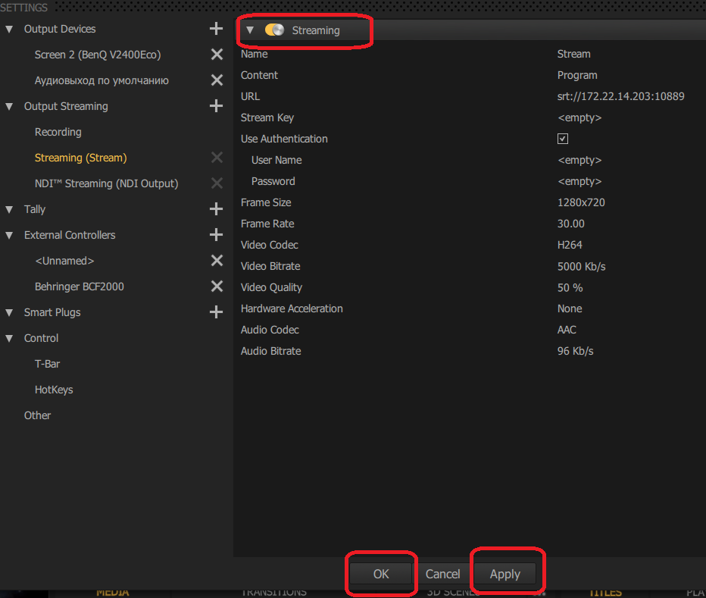

To start the stream, press the STREAM button

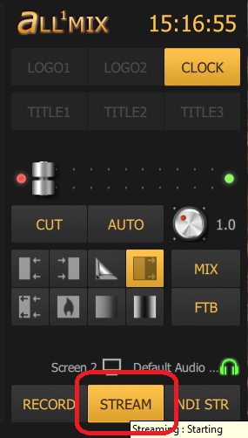

At first, the Stream button is highlighted in yellow and the broadcast status is "stopped" because there is no connection to the stream receiver. After connecting to the receiver, the button changes color to red and the stream is broadcast. If the connection is lost for too long, a timeout occurs, the button becomes inactive, and a broadcast error message is displayed.

1. **Setting the SRT input stream**

On the INPUT SLOTS panel, open the Network Stream tab and click +

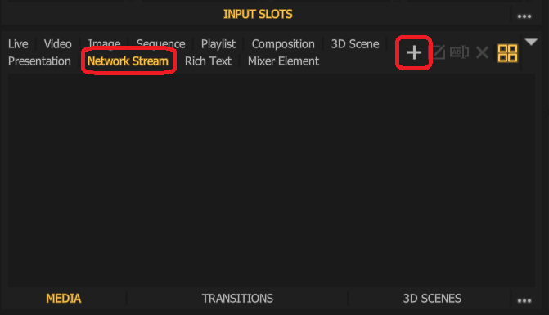

In the window that opens, fill in the Stream URL field:

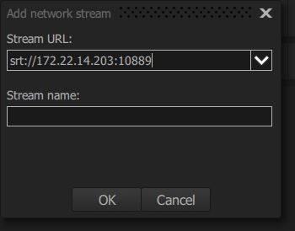

If you click on the icon , a list of previously entered addresses will open.

To accept the input SRT stream, you must enter the IP address and port of the computer on which the broadcast is already running (here it is srt://172.22.14.203:10889).

Click OK.

This stream will appear in the stream list:

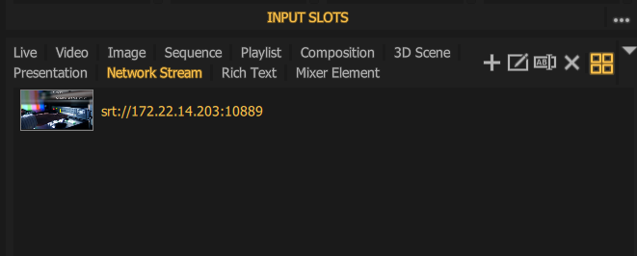

The name of the stream can be specified as any name, by default the network address is substituted as the name.